

School of Computing
and
Digital Technologies

Software Projects
(SEM2 AF-2025/6)

Individual Project

Name: Szu Szu Wang @ Hay Thar Htin Zaw
Student ID: 35008551
Degree Route: BEng SE

Table of Contents

1. Requirements Gathering Stage
1.1 Project Description and Users
1.2 User Stories and Acceptance Tests
2. Design Stage
2.1 Entity Relationship Diagram
2.2 Excalidraw Prototype
3. Development Stage
3.1 Transitioning a Prototype to Production-Quality Software
3.2 Test Description
4. Software and Its Presentation
4.2 The Production-Quality Software
4.3 Video Presentation
5. Evaluative Report on Legal, Social, Ethical and Professional Issues
5.1 Relevant Issues
5.2 Discussion
6. Incorporation of formative feedback
7. Use of AI declaration
8. References

1. Requirements Gathering Stage

1.1 Project Description and Users

Briefly outline your project in the context of a business. Who are the users in this context? Identify two users. If you identify more than two users, this will be fine, e.g.,

Name | Description
Doctor | Assigned to a department  Manage appointment slots and update patient diagnosis and prescriptions.
Nurse | Assigned to a ward  Record patient vitals and view patient medical records
Patient | Book appointments and view their personal info and medical records

1.2 User Stories and Acceptance Tests

Provide three user stories for each user you identified for the project. Provide a set of acceptance tests for each user story you identified, e.g.

ID | User Story | Notes | Acceptance Test
DOC-US-1  (Doctors, User Story 1) | As a doctor  I want to create my account  so that I can access the full features of the system. | Doctor already exists in DB but must set username, password, and phone number to log in. | - Given the doctor is on Sign Up page when they fill up all required information, then their account is created successfully.  - Given the doctor is on Sign Up page when their submitted name and email do not match with the ones saved in DB, then their account should not be created.  - Given the doctor has already signed in to their account when they try to sign up again, then a message of showing account already created is displayed.
DOC-US-2  (Doctors, User Story 2) | As a doctor  I want to add my appointment slots  so that patients can see and book the updated slots. | N/A | - Given the doctor is on Appointment Slots page when they click the Add Slot button, then they can choose time and date and add a new appointment slot.  - Given the doctor is on Appointment Slots page when they added a slot with a past date, then the slot is failed to be created.  - Given the doctor is adding a slot when they select a slot out of working time such as 4am, then the slot is failed to be created.
DOC-US-3  (Doctors, User Story 3) | As a doctor  I want to view my ready-to-consult, upcoming, completed, and missed appointments  so that I can track and manage my schedule. | N/A | - Given the doctor is on Appointment page when they select “Ready-to-consult”, “Upcoming”, “Past”, or “Missed” option, then the system displays all related appointments.  - Given the doctor is on Appointment page when their selected status option has no appointment, then a message of no appointment is displayed.  - Given the doctor wants to view details of a completed appointment when they click an appointment, then appointment and patient details is detailed.
DOC-US-4  (Doctors, User Story 4) | As a doctor  I want to book appointments for the patients  so that I can ensure the appointment is scheduled properly. | N/A | - Given the doctor is on Appointment page when they click the Book Appointment button, then they can book an appointment by inputting patient id and choosing a slot.  - Given the doctor is on Appointment page when there are no slots, then they will not be able to book an appointment.  - Given the doctor is booking an appointment for a patient when the patient already has an appointment on the chosen date and time, then the appointment should not be created.
NUR-US-1  (Nurses, User Story 1) | As a nurse  I want to create my account  so that I can access the full features of the system. | Nurse already exists in DB but must set username, password, and phone number to log in. | - Given the nurse is on Sign Up page when they fill up all required information, then their account is created successfully.  - Given the nurse is on Sign Up page when their submitted name and email do not match with the ones saved in DB, then their account should not be created.  - Given the nurse has already created their account when they try to sign up again then the error message of account already created is displayed.
NUR-US-2  (Nurses, User Story 2) | As a nurse  I want to add patient vitals  so that I can ensure all vitals is recorded before the appointment. | N/A | - Given the nurse is on Appointments page when they selected an upcoming appointment, then the system displays a form to add vitals for that patient of the appointment.  - Given the nurse is on Appointments page when they failed to enter all vitals, then the form is failed to submit.  - Given the appointment time has passed when the nurse failed to add the patient vitals, then the appointment is categorized as missed.
NUR-US-3  (Nurses, User Story 3) | As a nurse  I want to add patients and generate their temporary username and password  so that patient can create their account. | N/A | - Given the nurse is on Patient List page when they click the Add Patient button, then the system displays a form to add patient, then generate a temporary username and password for patients.  - Given the nurse is adding a patient when they enter the details of already created patient, then the creation will be failed.  - Given the nurse is adding a patient when all required fields are not filled, then the patient is not created.
PAT-US-1  (Patient, User Story 1) | As a patient  I want to book appointments  so that I can schedule an appointment when required. | N/A | - Given the patient is on Book Appointment page when they choose a slot of a doctor, then they are allowed to book the appointment of that date and time.  - Given the patient is on Book Appointment page when they choose a doctor with no slots, then both slots and book appointment button is not displayed.  - Given the patient is booking an appointment when they already have an appointment of the same date, then the appointment is not created.
PAT-US-2  (Patient, User Story 2) | As a patient  I want to update my personal info  so that I can ensure they are updated. | N/A | - Given the patient is on Personal Info page when they clicked the edit button, then the system allows to edit their personal details.  - Given the patient is on Personal Info page when they clear all information when editing, then the system will not allow submitting.  - Given the patient enters something wrong when editing when they click the reset button, then details of previous version is restored.
PAT-US-3  (Patient, User Story 3) | As a patient  I want to view my medical records  so that I can track all my treatments and diagnosis. | N/A | - Given the patient is on Medical Records page when there are medical records available, then the system displays all of them.  - Given the patient is on Medical Records page when there are no medical records, then the system displays a message to show there is none.  - Given the patient wants a detail view of a medical record when a record is clicked, then it expands to show the details.

2. Design Stage

2.1 Entity Relationship Diagram

The design must be annotated outlining the purpose of each entity within the design, e.g.,

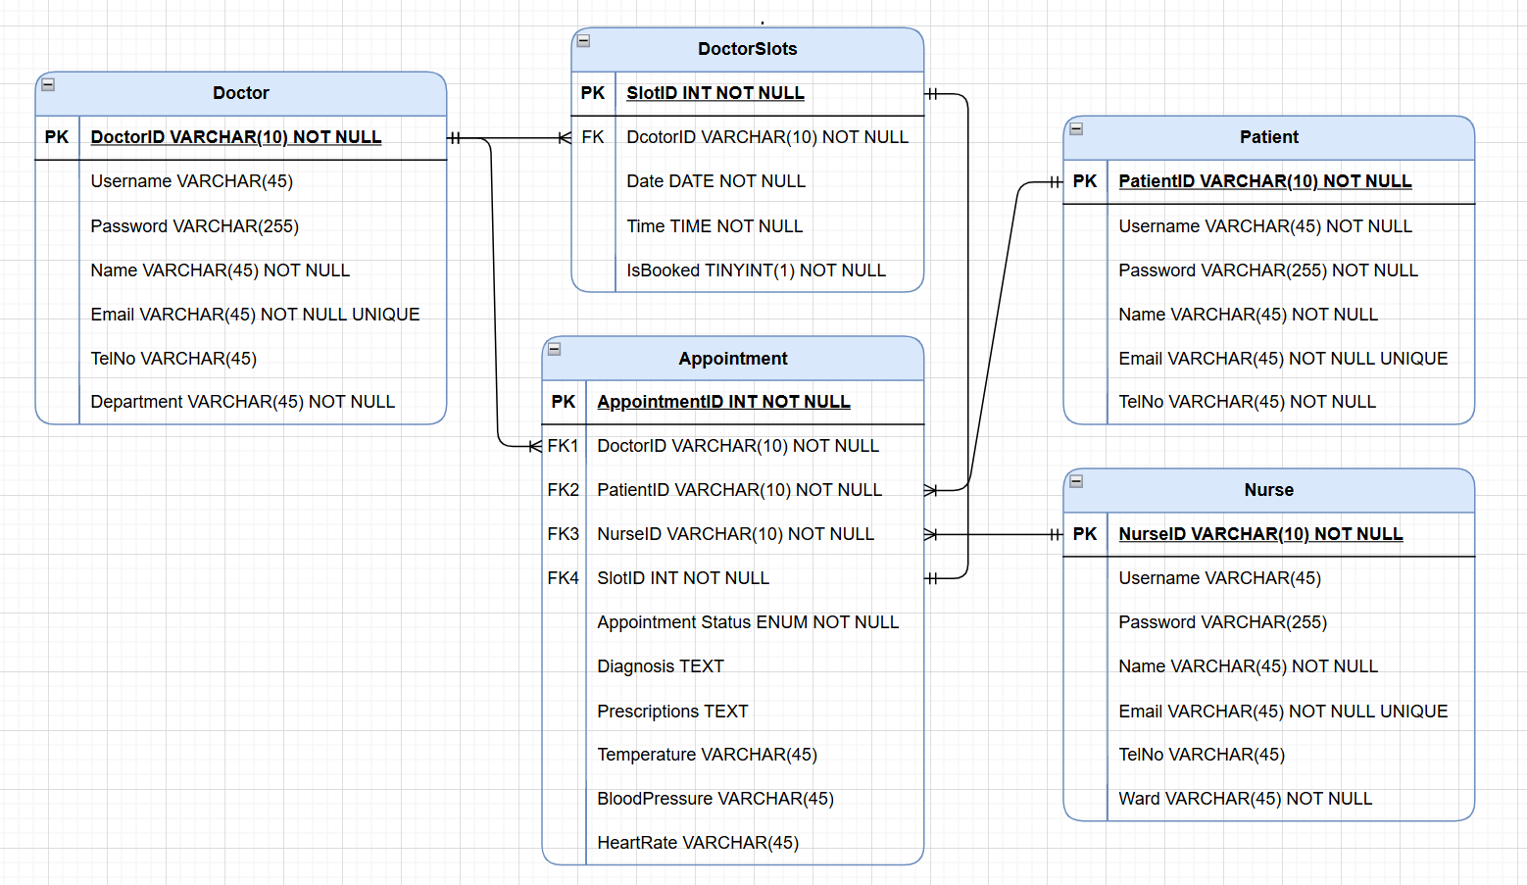

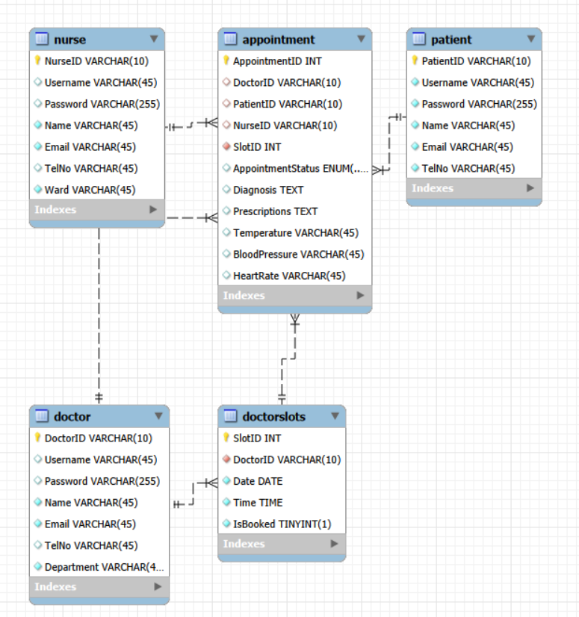

2.2 Excalidraw Prototype

Screenshots of your Excalidraw Prototype.

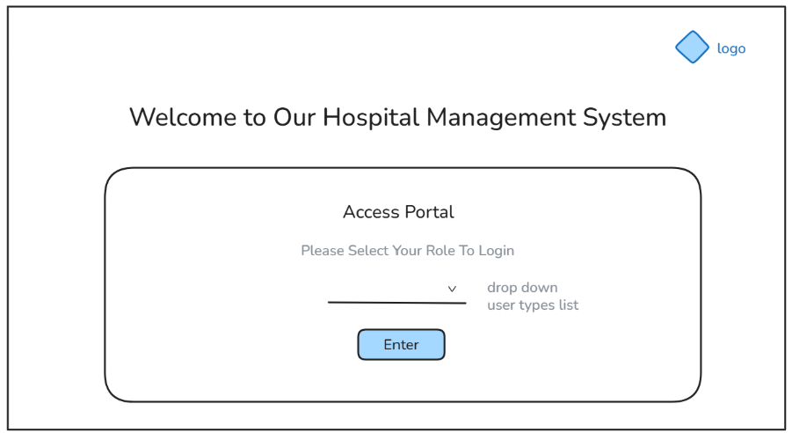
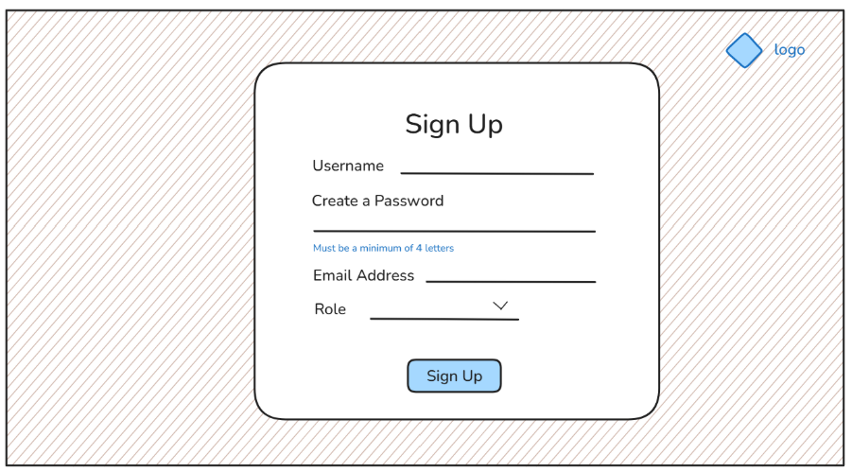
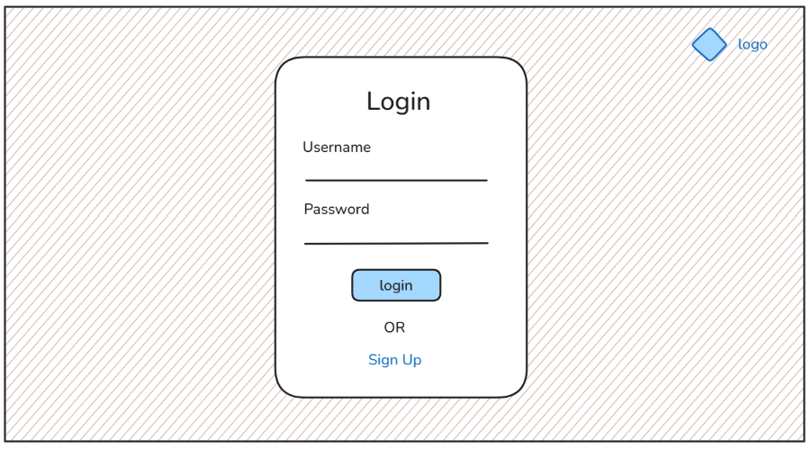
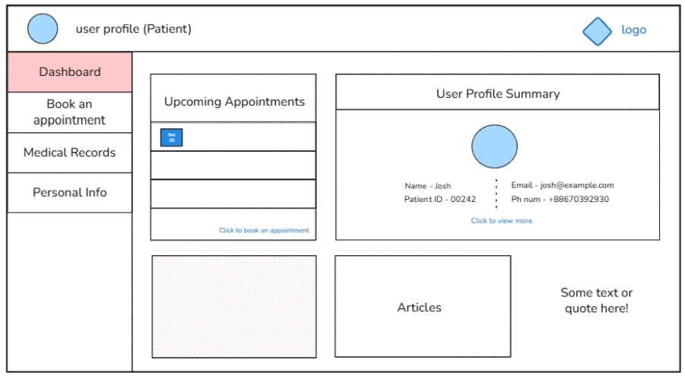
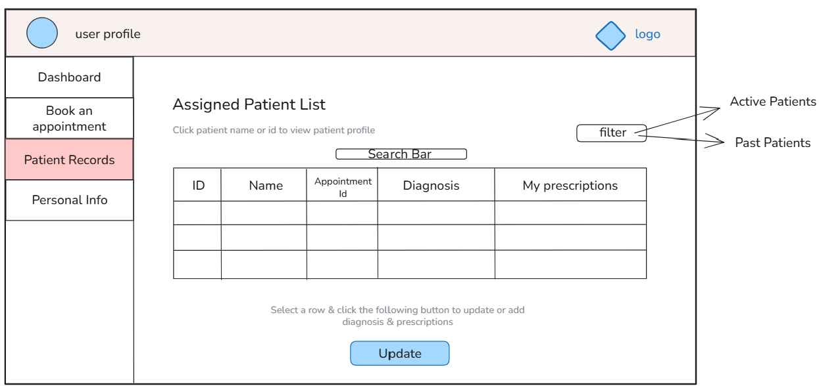
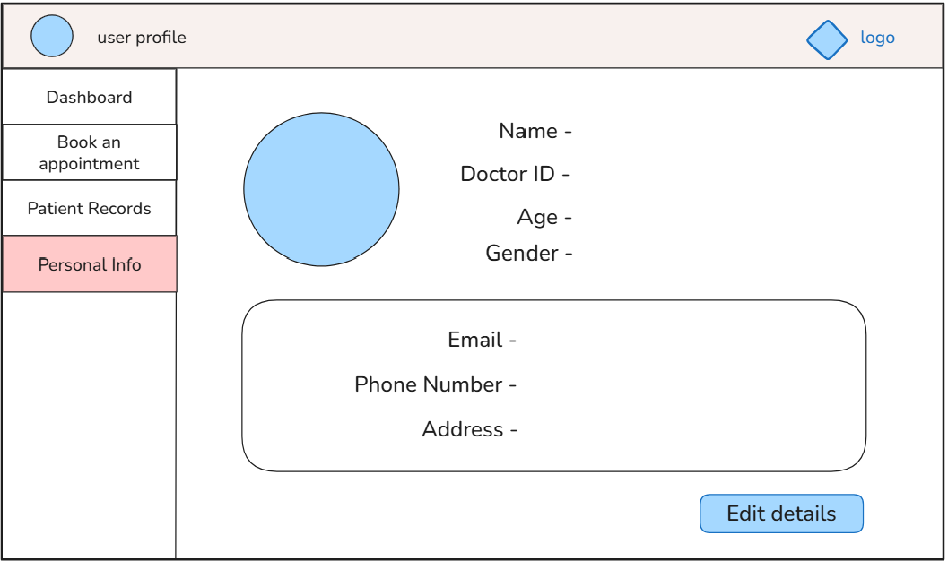

3. Development Stage

3.1 Transitioning a Prototype to Production-Quality Software

Following three pages are the evidence of the transition between my prototype to a production-quality software system. For a user-friendly interface, pages are introduced by its header, a brief introduction, and a warning or explanation message when necessary. The hospital logo has been added on all pages, and the styling of the page elements such as forms, inputs, and buttons remains consistent throughout the system. The system also emphasizes on responsive design, making it applicable on all devices.

Front-End Transitioning
Access Portal (developed using Excalidraw)

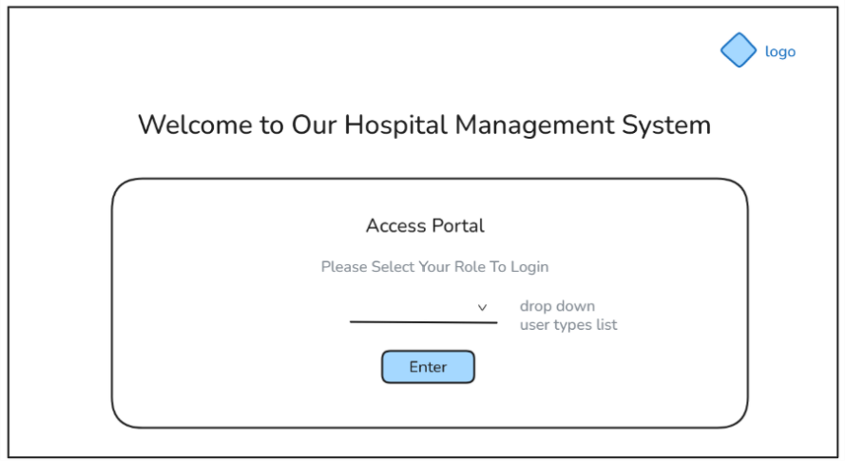

The Actual Access Portal (developed using HTML)

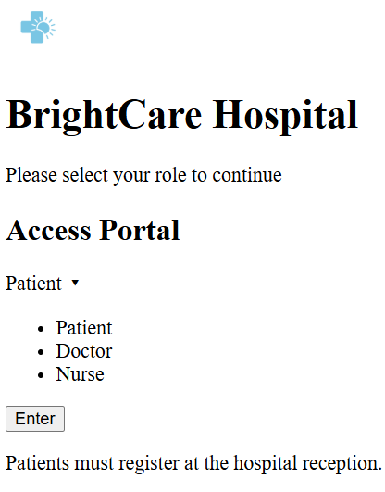 | 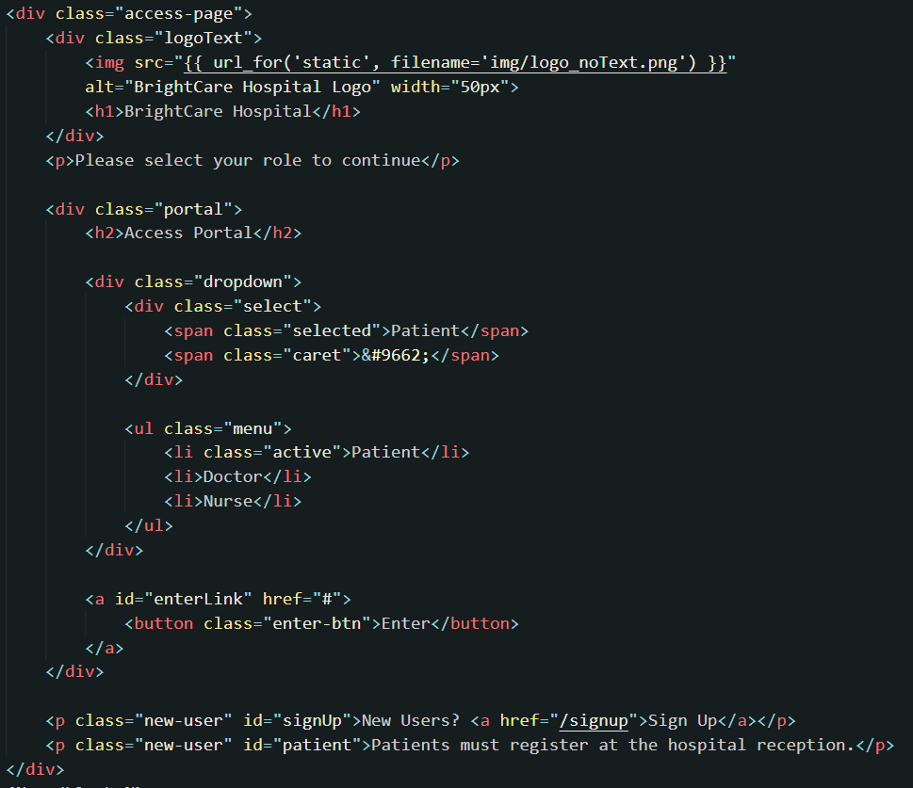

After applying CSS
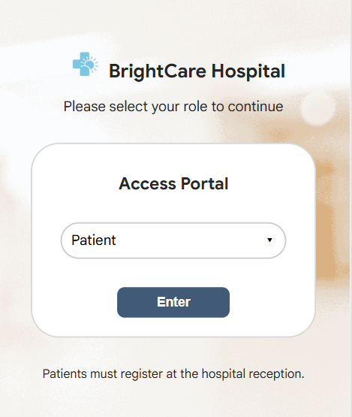 | 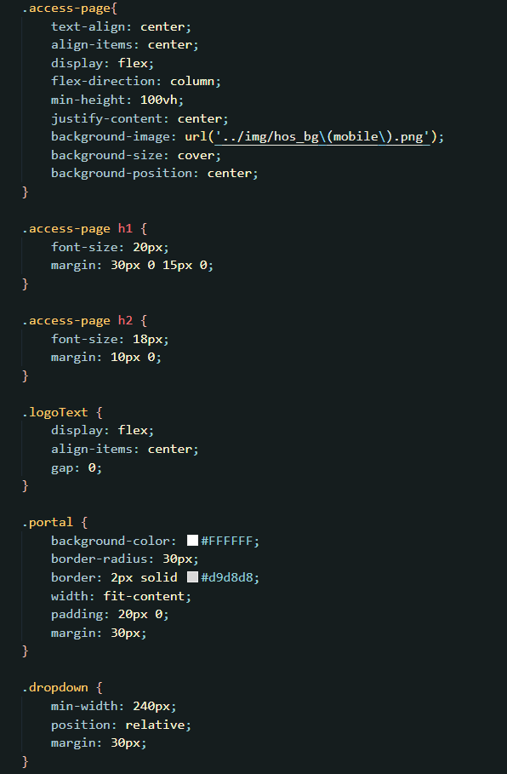

Login Page (developed using Excalidraw)

The Actual Login Page (developed using HTML)

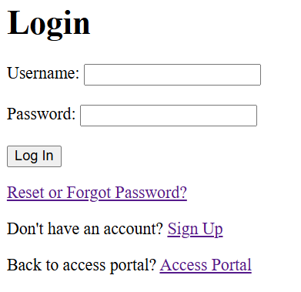 | 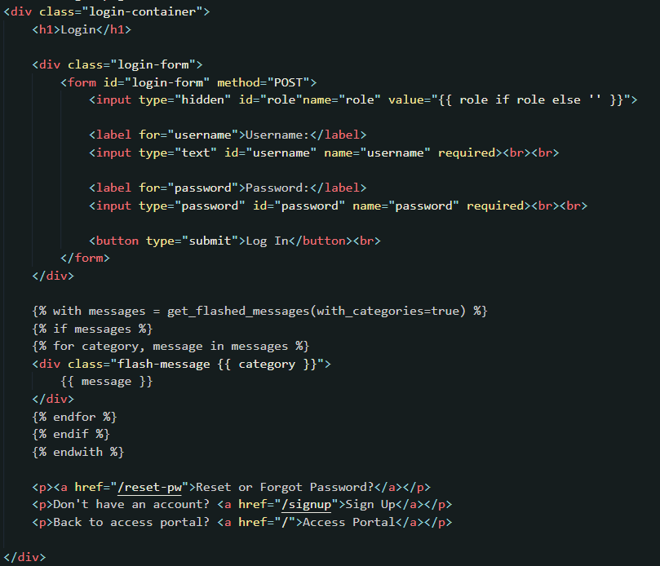

After applying CSS
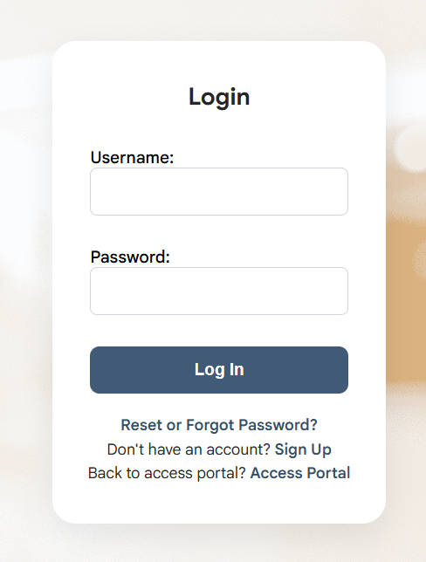 | 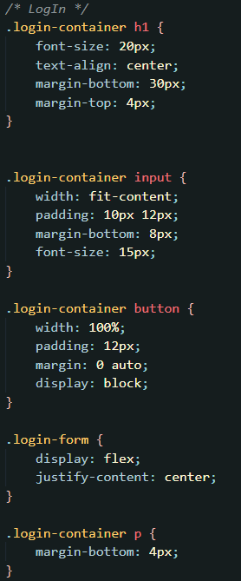

Doctor Dashboard (developed using Excalidraw)

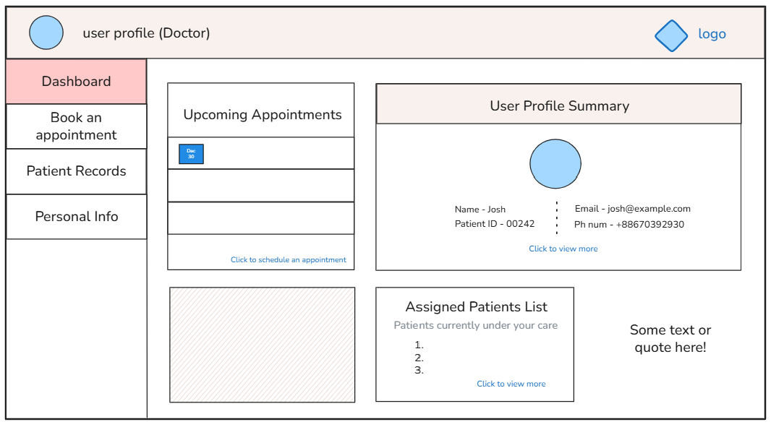

The Actual Doctor Dashboard (developed using HTML)

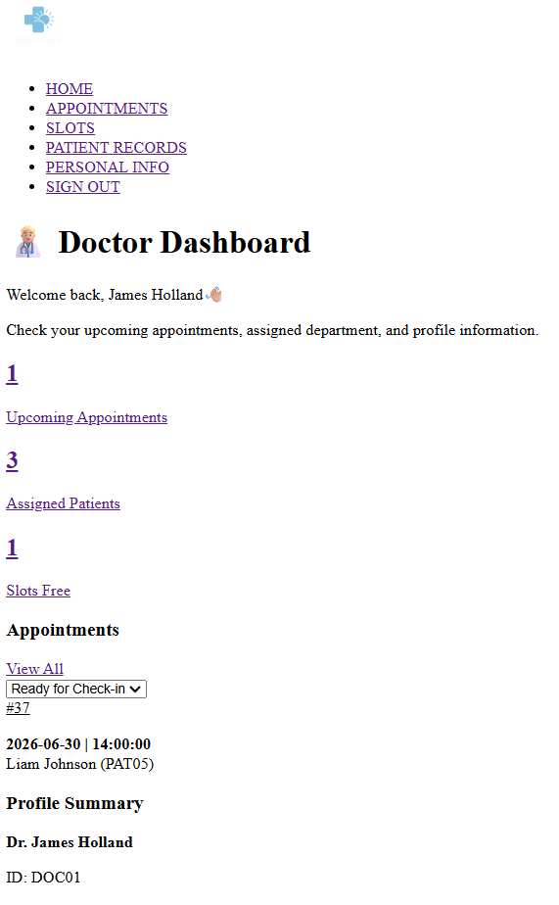 | 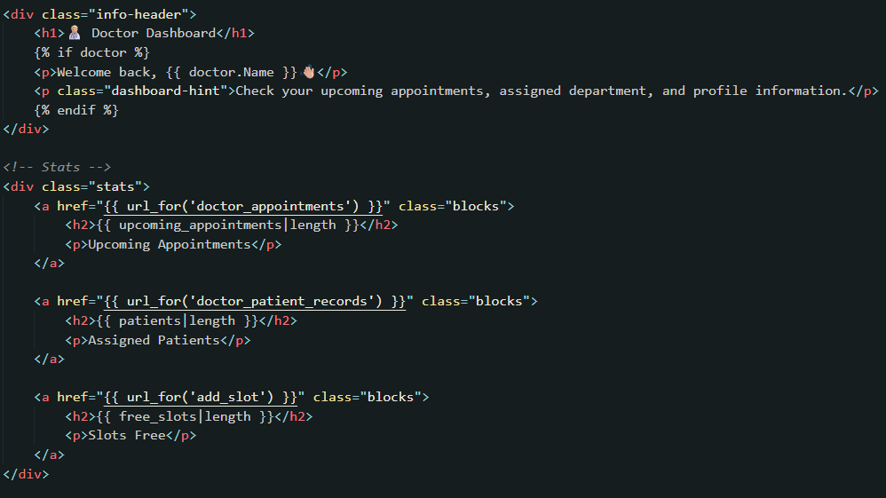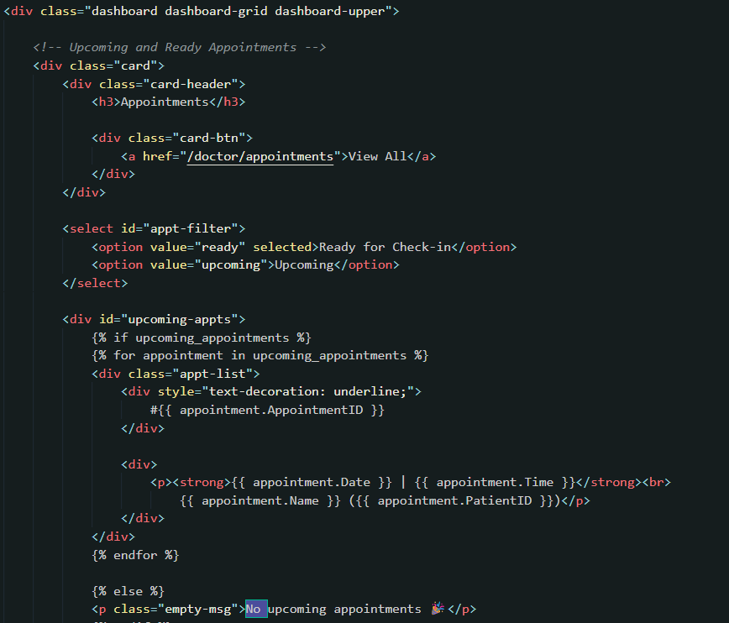

After applying CSS
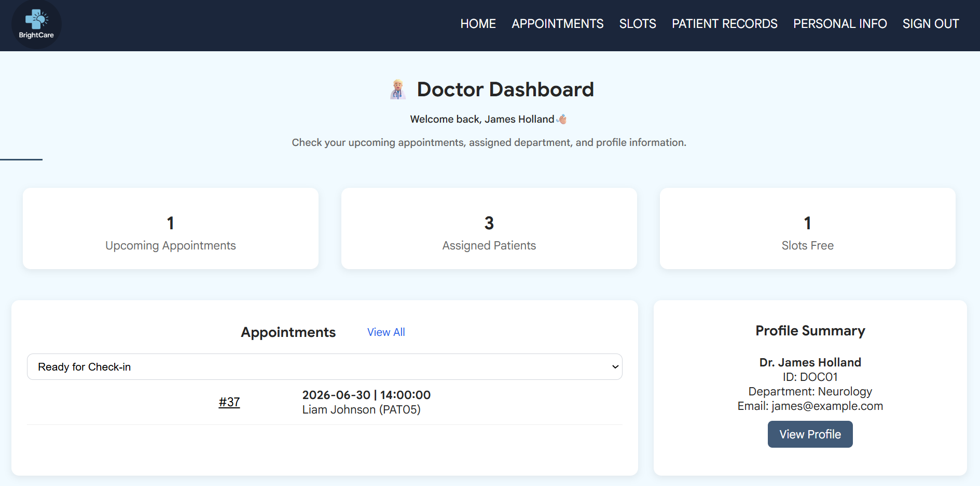  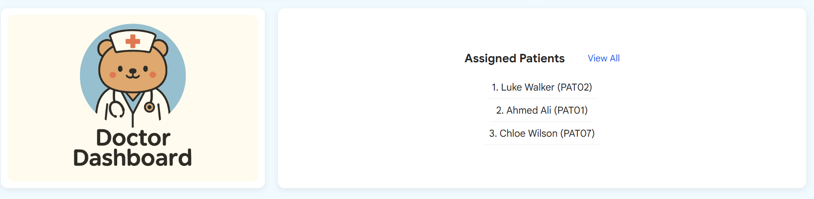 | 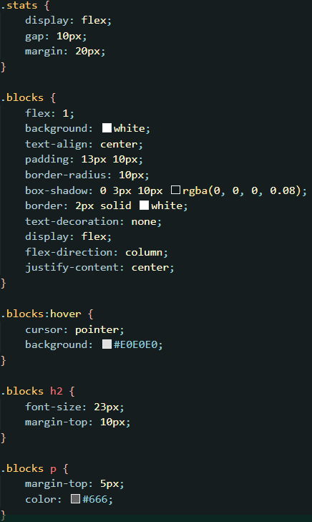

Back-End Transitioning

SQLite Database has been chosen to manage the database for the system. Data Definition Language (DDL) has been used to transform the ERD into database tables.

CREATE TABLE doctor (
DoctorID VARCHAR(10) NOT NULL,
Username VARCHAR(45),
Password VARCHAR(255),
Name VARCHAR(45) NOT NULL,
Email VARCHAR(45) NOT NULL,
TelNo VARCHAR(45),
Department VARCHAR(45) NOT NULL,
PRIMARY KEY (DoctorID),
UNIQUE (Email),
UNIQUE (Username)
);

CREATE TABLE nurse (
NurseID VARCHAR(10) NOT NULL,
Username VARCHAR(45),
Password VARCHAR(255),
Name VARCHAR(45) NOT NULL,
Email VARCHAR(45) NOT NULL,
TelNo VARCHAR(45),
Ward VARCHAR(45) NOT NULL,
PRIMARY KEY (NurseID),
UNIQUE (Email),
UNIQUE (Username)
);

CREATE TABLE patient (
PatientID VARCHAR(10) NOT NULL,
Username VARCHAR(45),
Password VARCHAR(255),
Name VARCHAR(45) NOT NULL,
Email VARCHAR(45) NOT NULL,
TelNo VARCHAR(45),
PRIMARY KEY (PatientID),
UNIQUE (Email),
UNIQUE (Username)
);

CREATE TABLE doctorslots (
SlotID INT NOT NULL AUTO_INCREMENT,
DoctorID VARCHAR(10) NOT NULL,
Date DATE NOT NULL,
Time TIME NOT NULL,
IsBooked TINYINT(1) NOT NULL DEFAULT 0,
PRIMARY KEY (SlotID),
UNIQUE (DoctorID, Date, Time),
FOREIGN KEY (DoctorID),
REFERENCES doctor(DoctorID)
ON DELETE CASCADE
ON UPDATE CASCADE)
);

CREATE TABLE appointment (
AppointmentID INT NOT NULL AUTO_INCREMENT,
DoctorID VARCHAR(10),
PatientID VARCHAR(10),
NurseID VARCHAR(10),
SlotID INT NOT NULL,
AppointmentStatus ENUM('Upcoming', 'VitalsSaved', 'Completed', 'Missed'),
Diagnosis TEXT,
Prescriptions TEXT,
Temperature VARCHAR(45),
BloodPressure VARCHAR(45),
HeartRate VARCHAR(45),
PRIMARY KEY (AppointmentID),
FOREIGN KEY (DoctorID),
REFERENCES doctor(DoctorID)
ON DELETE SET NULL
ON UPDATE CASCADE,
FOREIGN KEY (NurseID),
REFERENCES nurse(NurseID)
ON DELETE SET NULL
ON UPDATE CASCADE,
FOREIGN KEY (PatientID),
REFERENCES patient(PatientID)
ON DELETE SET NULL
ON UPDATE CASCADE,
FOREIGN KEY (SlotID),
FOREIGN KEY (`SlotID`)
REFERENCES doctorslots(SlotID)
ON DELETE RESTRICT
ON UPDATE CASCADE)
);

And Data Manipulation Language (DML) has been utilised to populate records for the tables.

When inserting the data, usernames, passwords, and telephone numbers are set to NULL. These are populated only when the users complete the sign-up process in the frontend. The populated passwords are then stored in hashed for data security. The minimum password length is 15 and passwords that are filled has the pattern of full name, plus role, and plus ‘pw’. If the pattern does not work, passwords can be reset.

Doctor DOC01:
Password: jameshollanddoctorpw

Nurse NUR04:
Password: gracemorgannursepw

Patient PAT01:
Password: ahmedalipatientpw

Additionally, the insert statements for slots and appointments are based on the initial seed data, while the current data has additional updates made during the system development.

--Doctor table
INSERT INTO Doctor (DoctorID, Username, Password, Name, Email, TelNo, Department)
VALUES
('DOC01', NULL, NULL, 'James Holland', 'james@example.com', NULL, 'Neurology'),
('DOC02', NULL, NULL, 'Sarah Willams', 'sarah@example.com', NULL, 'General Medicine'),
('DOC03', NULL, NULL, 'Daniel Thompson', 'daneil@example.com', NULL, 'General Medicine'),
('DOC04', NULL, NULL, 'Emily Carter', 'emily@example.com', NULL, 'Cardiology'),
('DOC05', NULL, NULL, 'John Smith', 'john@example.com', NULL, 'Neurology'),
('DOC06', NULL, NULL, 'Michael Brown', 'michael@example.com', NULL, 'Cardiology'),
('DOC07', NULL, NULL, 'Laura Green', 'laura@example.com', NULL, 'Orthopaedics'),
('DOC08', NULL, NULL, 'David Taylor', 'david@example.com', NULL, 'General Medicine'),
('DOC09', NULL, NULL, 'Chloe Martin', 'chloe@example.com', NULL, 'Orthopaedics'),
('DOC10', NULL, NULL, 'Noah Harris', 'noah@example.com', NULL, 'Cardiology');

--Nurse table
INSERT INTO Nurse (NurseID, Username, Password, Name, Email, TelNo, Ward)
VALUES
('NUR01', NULL, NULL, 'Sam Miller', 'sam@example.com', NULL, 'A'),
('NUR02', NULL, NULL, 'Emma Sterling', 'emma@example.com', NULL, 'B'),
('NUR03', NULL, NULL, 'Alice Kennedy', 'alice@example.com', NULL, 'C'),
('NUR04', NULL, NULL, 'Grace Morgan', 'grace@example.com', NULL, 'B'),
('NUR05', NULL, NULL, 'David Jackson', 'davidj@example.com', NULL, 'D'),
('NUR06', NULL, NULL, 'Alice Bennett', 'bennett@example.com', NULL, 'D'),
('NUR07', NULL, NULL, 'Jessica Moore', 'jessica@example.com', NULL, 'C'),
('NUR08', NULL, NULL, 'James Carter', 'jcarter@example.com', NULL, 'A'),
('NUR09', NULL, NULL, 'Aisha Khan', 'aisha@example.com', NULL, 'A'),
('NUR10', NULL, NULL, 'Hannah Wilson', 'hannah@example.com', NULL, 'B');

--Patient table
INSERT INTO `patient` (`PatientID`, `Username`, `Password`, `Name`, `Email`, `TelNo`) VALUES
('PAT01','PAT01','scrypt:32768:8:1$EPrzjrqZmb4dCEg7$77809e47e037cbf7e64d8319da731a5155bc8d5285ab618fddfbb63fc2a1813da44f72d6eb6c270d3c33cc59bec735a2340cee725636aa19a3f238b5699ee9f1','Ahmed Ali','ahmed@example.com','+447100233493'),
('PAT02','PAT02','scrypt:32768:8:1$IqKALqQVuojJOm62$f624a4234eb8055be05b77827f9301d3e8628ab04fb9d0bc60db1e0228dc29540eacc696f6745c112c288b33c764bd43e602d4de20608e7d4eea30e44de6fe09','Luke Walker','luke@example.com','+447213388453'),
('PAT03','PAT03','scrypt:32768:8:1$zmjZC3BCUNhzI8BI$e74e4f5587657b28de773bd27ce543ec42d67b99c1afa1a466e0d6d196e72ff62e1e2c00c2f072d4700833e11db936042510dd34ba254076b99453602aa04a05','Sarah Collins','sCollins@example.com','+447389442713'),
('PAT04','PAT04','scrypt:32768:8:1$EiS9JpVxwslxLL6q$94f76c417b4b10a3f359094c9f879d4b869fd46c562fbff951dfdacccf3d7e19468760e12ec1acd6512f954e033789e5b30c9d6baec9c0c8cfb1b51e228ad1e2','Olivia Brown','olivia@example.com','+447120047329'),
('PAT05','PAT05','scrypt:32768:8:1$HewA5lebySr0HGUz$66c18c5254e40162b6118725003d57bafc475bedfdc58732dbe046f09071e841a03538cf61a9dd3556be46a2e2ea17ba6ceb32c8fd17b69f8458e822ea6d85b5','Liam Johnson','liam@example.com','+447038233749'),
('PAT06','PAT06','scrypt:32768:8:1$hM0i7nyKYNX02Gv5$77bea21ad76dc0c04a73549832463e833d16e53706b0c85d90a225ffc17969547a28c8dc807869a95f0c23b612f8d50155242c94a5878e0b671f5dfc97457c99','Emma Thompson','ethompson@example.com','+447350649332'),
('PAT07','PAT07','scrypt:32768:8:1$HACqh9JhVPNHpkXP$852eb64db6eda06c4c217251f8e15c3762a6c3f8c7c2c657822357dbe2172c8a5d5ab63ce1ca95a9a1e48d18aa6c4bd41a601236e850cab75fc6c9444be9cfdc','Chloe Wilson','cwilson@example.com','+4471298348756'),
('PAT08','PAT08','scrypt:32768:8:1$VKkMmUWgcYLFjRZE$046177d211f42e58b6a758de1bcf356dce55e5239b16ade20ade0b784ac01d072435c52f1ffb80ccafcaecc08dd65e2b397525e4be08b9fed9b7ab00d494a683','Mohammed Rahman','mohammed@example.com','+447203992128'),
('PAT09','PAT09','scrypt:32768:8:1$uYvXVKHOEYbRUT3k$92b9a70ce5cfb80047dddd93b8d28cab6b1100b0ab8654c8a9a4c97aee643d8f73c64b17baaef543cc7c93d3b210de1b1bc9761f2a84d1d1d5e422a7457b8b5f','Robert Taylor','robert@example.com','+447034885239'),
('PAT10','PAT10','scrypt:32768:8:1$wvZa9jDSVwqeoDQQ$076d492e8700660f81c28414cfa0f56d73ee916a8f02ef4c648675e3e0ff920a9fe9c69fcf803a57b375e58e78e0a96d189dd45e21dff526de47f3fb5dfa55c9','John Williams','jwilliams@example.com','+447650112938'),
('PAT11','PAT11','scrypt:32768:8:1$xjH6fCSqNzAZ993w$a6eb6543cafa324e0aa9ce0be7c78ded112a5e69e10effd31fe2d2ac9c963d8dbffff7fc19e9f709ab804db5339a3c074669d1e4822e53923cad1c44cfcaec61','Hay Thar','haythar@gmail.com','+447112233440');

--Doctorslots table
INSERT INTO Doctorslots (DoctorID, Date, Time, IsBooked)
VALUES
-- DOC01
('DOC01', '2026-02-10', '09:30:00', 1),
('DOC01', '2026-02-10', '11:00:00', 1),
('DOC01', '2026-02-10', '11:30:00', 1),
('DOC01', '2026-02-11', '13:00:00', 0),
('DOC01', '2026-02-11', '14:30:00', 1),

-- DOC02
('DOC02', '2026-02-10', '10:00:00', 1),
('DOC02', '2026-02-11', '10:00:00', 1),
('DOC02', '2026-02-11', '11:30:00', 1),
('DOC02', '2026-02-11', '13:00:00', 0),
('DOC02', '2026-02-11', '14:00:00', 1),

-- DOC03
('DOC03', '2026-02-10', '09:30:00', 1),
('DOC03', '2026-02-10', '13:00:00', 0),
('DOC03', '2026-02-11', '11:30:00', 1),
('DOC03', '2026-02-12', '13:00:00', 0),
('DOC03', '2026-02-12', '13:30:00', 0),

-- DOC04
('DOC04', '2026-02-10', '10:30:00', 1),
('DOC04', '2026-02-11', '11:00:00', 1),
('DOC04', '2026-02-11', '11:30:00', 1),
('DOC04', '2026-02-12', '15:00:00', 0),
('DOC04', '2026-02-12', '15:30:00', 1),

-- DOC05
('DOC05', '2026-02-11', '09:30:00', 0),
('DOC05', '2026-02-11', '14:00:00', 0),
('DOC05', '2026-02-12', '15:30:00', 1),
('DOC05', '2026-02-12', '16:00:00', 0),
('DOC05', '2026-02-13', '10:30:00', 1),

-- DOC06
('DOC06', '2026-02-10', '15:30:00', 1),
('DOC06', '2026-02-11', '13:00:00', 1),
('DOC06', '2026-02-12', '10:00:00', 0),
('DOC06', '2026-02-13', '15:00:00', 0),
('DOC06', '2026-02-13', '16:30:00', 1),

-- DOC07
('DOC07', '2026-02-10', '16:00:00', 1),
('DOC07', '2026-02-12', '15:00:00', 1),
('DOC07', '2026-02-13', '10:30:00', 1),
('DOC07', '2026-02-13', '13:00:00', 0),
('DOC07', '2026-02-13', '15:30:00', 1),

-- DOC08
('DOC08', '2026-02-10', '09:30:00', 1),
('DOC08', '2026-02-10', '13:00:00', 0),
('DOC08', '2026-02-10', '16:30:00', 0),
('DOC08', '2026-02-11', '14:00:00', 0),
('DOC08', '2026-02-11', '14:30:00', 1),

-- DOC09
('DOC09', '2026-02-12', '11:30:00', 0),
('DOC09', '2026-02-12', '15:00:00', 0),
('DOC09', '2026-02-13', '11:00:00', 1),
('DOC09', '2026-02-14', '10:00:00', 0),
('DOC09', '2026-02-14', '09:30:00', 1),

-- DOC10
('DOC10', '2026-02-10', '16:00:00', 0),
('DOC10', '2026-02-12', '10:00:00', 1),
('DOC10', '2026-02-13', '13:30:00', 1),
('DOC10', '2026-02-13', '14:00:00', 0),
('DOC10', '2026-02-14', '15:30:00', 0);

--Appointment table
INSERT INTO Appointment (DoctorID, PatientID, NurseID, SlotID, AppointmentStatus, Diagnosis, Prescriptions, Temperature, BloodPressure, HeartRate)
VALUES
('DOC01', 'PAT07', 'NUR03', 506 , 'Completed', 'Common Cold', 'Paracetamol 500mg', '99.7', '120/80', '75'),
('DOC01', 'PAT01', 'NUR02', 505 , 'Completed', 'Diabetes Checkup', 'Metformin 500mg', '99.2', '130/85', '73'),
('DOC01', 'PAT02', 'NUR10', 508 , 'Upcoming', NULL, NULL, NULL, NULL, NULL),
('DOC02', 'PAT06', 'NUR10', 509 , 'Completed', 'Common Cold', 'Paracetamol 500mg', '98.6', '118/76', '76'),
('DOC02', 'PAT08', 'NUR04', 510 , 'Upcoming', NULL, NULL, NULL, NULL, NULL),
('DOC02', 'PAT09', 'NUR08', 511 , 'Upcoming', NULL, NULL, NULL, NULL, NULL),
('DOC02', 'PAT10', 'NUR05', 513 , 'Missed', NULL, NULL, NULL, NULL, NULL),
('DOC03', 'PAT03', 'NUR07', 514 , 'Completed', 'Hypertension', 'Amlodipine 5mg OD', '97.9', '140/90', '78'),
('DOC03', 'PAT05', 'NUR04', 516 , 'Missed', NULL, NULL, NULL, NULL, NULL),
('DOC04', 'PAT04', 'NUR06', 519 , 'Completed', 'Flu', 'Oseltamivir 75mg BID', '99.1', '118/76', '80');

Due to varying functionalities, dashboards are unique based on the user role. The following code of Access Portal is used to fetch the user role and store it to the backend, which is later used for redirecting to their dashboards.

@app.route("/")
def access():
return render_template("access-portal.html", show_menu=False, show_footer=False, role=None)

//the role is being checked on every page backend using these codes
if request.method == "POST":
role = request.form.get("role") or request.args.get("role")

table_map = {
"doctor": "doctor",
"nurse": "nurse",
"patient": "patient"
}

if role not in table_map:
flash("Invalid role.", "error")
return redirect(f"/login?role={role}")

//if the role does not match, the following code always redirects back to the access portal page to avoid malicious access to the system.
if "user_id" not in session or session.get("role") != "doctor":
return redirect("/")

Similarly, the entered username, password, and role selected on the access control page is sent to the backend /login route by the POST method, checking for a matching record in the database. After the authentication, the user’s ID, username, and role are stored to session variables, and allows the user to log in to their personal dashboard. The flashing system is then used to send error messages to the frontend as a response to user or system errors.
@app.route("/login", methods=["GET", "POST"])
def login():
if request.method == "POST":
role = request.form.get("role") or request.args.get("role")

if request.method == "POST":
username = request.form.get("username")
password = request.form.get("password")

conn = mysql.connector.connect(**db_config)
cursor = conn.cursor(dictionary=True)

table_map = {
"doctor": "doctor",
"nurse": "nurse",
"patient": "patient"
}

if role not in table_map:
flash("Invalid role.", "error")
return redirect(f"/login?role={role}")

cursor.execute(f"SELECT * FROM {table_map[role]} WHERE Username = %s", (username,))
user = cursor.fetchone()

cursor.close()
conn.close()

if user:
if user["Password"] is None:
flash("Account not registered yet. Please sign up!", "error")
return redirect(f"/login?role={role}")

if check_password_hash(user["Password"], password):
id_role = {
"doctor": "DoctorID",
"nurse": "NurseID",
"patient": "PatientID"
}

session["user_id"] = user[id_role[role]]
session["username"] = user["Username"]
session["role"] = role

return redirect(f"/{role}")

flash("Invalid username or password.", "error")
return redirect(f"/login?role={role}")

return render_template("login.html", show_menu=False, show_footer=False)

Finally, the doctor dashboard homepage, just as other homepages, is the showcase of all pages’ shortcuts. Accordingly, each part fetches data by limiting a count of 5. When displaying the free slots status, timestamp() and now() functions are used for real-time comparisons, retrieving slots of earlier than the current date and time. This logic is applied for all appointments and slots backends.

@app.route("/doctor")
def doctor_dashboard():
if "user_id" not in session or session.get("role") != "doctor":
return redirect("/")

conn = mysql.connector.connect(**db_config)
cursor = conn.cursor(dictionary=True)

cursor.execute("SELECT DoctorID, Name, Email, Department FROM Doctor WHERE DoctorID = %s", (session["user_id"],))

doctor = cursor.fetchone()

# upcoming appts
cursor.execute("""
SELECT a.AppointmentID, a.PatientID, d.Date, d.Time, p.Name
FROM Appointment a
JOIN DoctorSlots d ON a.SlotID = d.SlotID
JOIN Patient p ON a.PatientID = p.PatientID
WHERE d.DoctorID = %s AND a.AppointmentStatus = 'Upcoming'
ORDER BY d.Date, d.Time
LIMIT 5
""", (session["user_id"],))
upcoming_appointments = cursor.fetchall()

# ready to consult
cursor.execute("""
SELECT a.AppointmentID, a.PatientID, d.Date, d.Time, p.Name
FROM Appointment a
JOIN DoctorSlots d ON a.SlotID = d.SlotID
JOIN Patient p ON a.PatientID = p.PatientID
WHERE d.DoctorID = %s AND a.AppointmentStatus = 'VitalsSaved'
ORDER BY d.Date, d.Time
LIMIT 5
""", (session["user_id"],))
ready_appointments = cursor.fetchall()

# Patient list
cursor.execute("""
SELECT p.PatientID, p.Name, MAX(a.AppointmentID) AS LatestAppointment
FROM Patient p
JOIN Appointment a ON p.PatientID = a.PatientID
JOIN DoctorSlots d ON a.SlotID = d.SlotID
WHERE d.DoctorID = %s AND a.AppointmentStatus = 'Completed'
GROUP BY p.PatientID, p.Name
ORDER BY LatestAppointment DESC
LIMIT 5
""", (session["user_id"],))

patients = cursor.fetchall()

# Free Slots
cursor.execute("""
SELECT SlotID, Date, Time
FROM DoctorSlots
WHERE DoctorID = %s
AND IsBooked = 0
AND TIMESTAMP(Date, Time) >= NOW()
ORDER BY Date, Time
""", (session["user_id"],))

free_slots = cursor.fetchall()

cursor.close()
conn.close()

return render_template("doctor/dashboard.html", show_menu=True, show_footer=True, role="doctor", doctor=doctor, upcoming_appointments=upcoming_appointments, ready_appointments=ready_appointments, patients=patients, free_slots=free_slots)

3.2 Test Description

In this sub-section, you are required to outline your test description with evidence (i.e., test results).

User Story ID | Test ID | Acceptance Test | Test Description | Expected Result | Test Result
DOC-US-1 | T001-DOC-US-1 | - Given the doctor is on Sign Up page when they fill up all required information, then their account is created successfully. | - On the role-based access control page, click the link to sign up below and a sign-up page will appear.  - Fill in your username, password, email, and select your role.  - Click ‘Sign Up’ button to submit your details to database. | User will be successfully created their account. | Pass
DOC-US-1 | T002-DOC-US-2 | - Given the doctor is on Sign Up page when their submitted name and email do not match with the ones saved in DB, then their account should not be created. | - Repeat step (1) in T002-DOC-US-1.  - Click ‘Sign Up’ button with incorrect details or without filling all fields.  - An error message of “Please ensure all fields are filled correctly” will be displayed. | User will not be successfully created their account. | Pass
DOC-US-2 | T003-DOC-US-2 | - Given the doctor is on Appointment Slots page when they click the Add Slot button, then they can choose time and date and add a new appointment slot. | - On the Slots page, click the add slot button.  - Choose a valid date and time on the form.  - Click the add button to create new slot. | The added slots will appear on the Slots page. | Pass
DOC-US-2 | T004-DOC-US-2 | - Given the doctor is on Appointment Slots page when they added a slot with a past date, then the slot is failed to be created. | - Repeat step (1) in T003-DOC-US-2.  - Choose a past date or a time out of working time (8-5) and submit.  - An error message will be displayed. | The page will be refreshed and the error message is displayed. | Pass
DOC-US-3 | T004-DOC-US-3 | - Given the doctor is on Appointment page when they select “Ready-to-consult”, “Upcoming”, “Past”, or “Missed” option, then the system displays all related appointments. | - On the Appointment page, select an appointment status from dropdown options. | Corresponding appointments are displayed based on chosen option. | Pass
DOC-US-3 | T005- DOC- US-3 | - Given the doctor is on Appointment page when their selected status option has no appointment, a message of no appointment is displayed. | - Repeat step (1) in T004-DOC-US-3. | A message of no appointment and an image is displayed. | Pass
DOC-US-4 | T006-DOC-US-4 | - Given the doctor is on Appointment page when they click the Book Appointment button, then they can book an appointment by inputting patient id and choosing a slot. | - Go to Appointments page from doctor dashboard.  - Click “Book Appointment” button to display the pop-up form.  - Select a slot from drop down list of available slots.  - Input correct patient id  - Click “Book Appointment” button or press enter key | The appointment will be booked and appear under “Upcoming Appointments” section with its details. | Pass
DOC-US-4 | T007- DOC- US-4 | - Given the doctor is on Appointment page when there are no slots, then they will not be able to book an appointment. | - Repeat step (1) to (2) in T006-DOC-US-4.  - Slot options will not appear | Appointment will be failed to book. | Pass
NUR-  US-1 | T008- NUR- US-1 | - Given the nurse is on Sign Up page when they fill up all required information, then their account is created successfully. | - On the role-based access control page, click the link to sign up below and a sign-up page will appear.  - Fill in your username, password, email, and select your role.  - Click ‘Sign Up’ button to submit your details to database. | User will be successfully created their account. | Pass
NUR-  US-1 | T009- NUR- US-1 | - Given the nurse is on Sign Up page when their submitted name and email do not match with the ones saved in DB, then their account should not be created. | - Repeat step (1) in T009-NUR-US-1.  - Click ‘Sign Up’ button with incorrect details or without filling all fields.  - An error message of “Please ensure all fields are filled correctly” will be displayed. | User will not be successfully created their account. | Pass
NUR-  US-2 | T010- NUR- US-2 | - Given the nurse is on Appointments page when they select an upcoming appointment, then the system displays a form to add vitals for that patient of the appointment. | - Go to Appointments page on Nurse Dashboard.  - Click on an upcoming appointment.  - A form is displayed to enter vitals for that patient.  - Click add button or enter. | The vitals will be added to the appointment and patient. | Pass
NUR-  US-2 | T011- NUR- US-2 | - Given the nurse is on Appointments page when they failed to enter all vitals, then the form is failed to submit. | - Repeat step (1) to (3) in T011-NUR-US-2.  - Click add button without filling all details.  - An error message is displayed. | The vitals are failed to be added. | Pass
NUR-US-3 | T012-NUR-US-3 | - Given the nurse is on Patient List page when they click the Add Patient button, then the system displays a form to add patient, then generate a temporary username and password for patients. | - Click the Add Patient button on Patient List page.  - A form is displayed to enter patient details.  - Enter all details and submit the form.  - A new form is displayed with newly generated username and password for that patient. | Patient is added to the list | Pass
NUR-US-3 | T013- NUR- US-3 | - Given the nurse is adding a patient when they enter the details of already created patient, then the creation will be failed. | - Repeat step (1) to (2) in T012-NUR-US-3.  - Input only partial information or no information.  - An error message is displayed. | Patient is failed to be created | Pass
PAT- US-1 | T014- PAT- US-1 | - Given the patient is on Book Appointment page when they choose a slot of a doctor, then they are allowed to book the appointment of that date and time. | - Go to Appointments page.  - Under Book New Appointment section, select a department from drop down list.  - Doctors from the selected department is displayed below.  - Choose a doctor and available slots for that doctor are displayed below.  - Choose a slot.  - Book Appointment button appeared then and click it to book that slot. | The appointment is booked and will appear under Upcoming Appointments. | Pass
PAT- US-1 | T015- PAT- US-1 | - Given the patient is on Book Appointment page when they choose a doctor with no slots, then both slots and book appointment button is not displayed. | - Repeat step (1) to (3) in T014-PAT-US-1.  - Choose a doctor.  - If the doctor does not have available slots, a message of no slots available is displayed. | Book appointment button will not appear. | Pass
PAT- US-2 | T016- PAT- US-2 | - Given the patient is on Personal Info page when they clicked the edit button, then the system allows to edit their personal details. | - Click the edit button on Personal Info page.  - Update any information.  - Click save changes button. | The information will be updated both on UI and database. | Pass
PAT- US-2 | T017- PAT- US-2 | - Given the patient is on Personal Info page when they clear all information when editing, then the system will not allow submitting. | - Repeat step (1) in T016-PAT-US-2.  - Clear all data or enter invalid information.  - Click save changes button.  - An error message is displayed | The form cannot be submitted. | Pass
PAT-US-3 | T018- PAT- US-3 | - Given the patient is on Medical Records page when there are medical records available, then the system displays all of them. | - Go to the Medical Records page on Patient Dashboard.  - Click an appointment.  - Appointment details such as diagnosis, prescriptions, and vitals are displayed. | Appointment details are shown as the appointment block is clicked or expanded. | Pass
PAT-US-3 | T019- PAT- US-3 | - Given the patient is on Medical Records page when there are no medical records, then the system displays a message to show there is none. | - Repeat step (1) in T018-PAT-US-3.  - A message of no medical records is displayed. | A clear message of no medical records and a navigation link to book appointment page will be displayed. | Pass

4. Software and Its Presentation

4.2 The Production-Quality Software

You are expected to submit the project, including all its components (e.g., codebase), compressed in a zip file (or 7z). The file should be named “IndividualProject_StudentNo” and must be uploaded to Blackboard as directed in the relevant submission point. (e.g., IndividualProject_32212112.zip)

4.3 Video Presentation

The project must be showcased in a video recording of up to 15 minutes. We will stop watching after the 15th minute.

https://shu.cloud.panopto.eu/Panopto/Pages/Viewer.aspx?id=0178858f-c48b-4f2c-901b-b43c00c222ea

5. Evaluative Report on Legal, Social, Ethical and Professional Issues

5.1 Relevant Issues

Identify two or three issues that specifically relate to your project (this could be GDPR, copyright, accessibility, testing, etc.) and briefly explain their relevance to your project.

- Data Privacy
Ensuring data privacy is crucial, as the system stores sensitive patient information, including personal data, appointments, and medical records. This information must be protected from unauthorized access and handled in compliance with legal standards like GDPR.

- Accessibility
A Hospital Management System may be used by various types of users, potentially including patients with physical impairments. Thus, accessibility and inclusion should be one of the most essential components of this system. It is important to ensure every user can access same information and perform same procedures and tasks.

- Data Accuracy
Data accuracy is essential. This is because incorrect patient, appointment, or medical information in the system could lead to serious consequences, such as scheduling errors or false treatment being given to the wrong patient. Therefore, the system must ensure all data should be kept accurate and up to date.

5.2 Discussion

Discuss what impact these will have on the project. Specifically, you may discuss how these issues will impact on the way you will transition your prototype / design you developed in Requirements and Design stage to a production-quality (where possible). As well as supporting your discussion with references, throughout your work you are also expected to identify recent public examples that have been reported in the news (or other reputable sources), for example if you are creating an application that will store personal data, a useful example would be to mention the fine British Airways received for being in breach of GDPR, all of which should be cited using the APA 7 format.
These three issues have a great impact on how my prototype is transitioned into a production-quality system. First, to address data privacy, the system uses hashed passwords instead of storing them in a plain text. The Python secrets module is then used to generate a secret key with strong random numbers and stored securely in an .env file. These measures ensure compliance with GDPR and prevent unauthorized access or data breaches. Data protection is very essential, as failure to comply can have severe consequences; for example, British Airways was fined £20 million in 2018 for a data breach that exposed extensive customer and staff information due to poor security measures (BBC News, 2020). Similarly, the Clearview AI was alleged for its unlawful usage of people images and personal data, resulting in a massive financial penalty of €20 million (Van Haperen Paula Barrett Nils Müller Robbert Santifort, 2024).
Accessibility is also a core consideration: the system adheres to the Web Content Accessibility Guidelines (WCAG 2.2), ensuring equal access for all users. It supports keyboard navigation, high-contrast interfaces, informative, and understandable layouts, and includes text alternatives for all images. The Equality Act 2010 enforces accessibility, as illustrated when a Disabled Students’ Allowance form was deemed inaccessible to screen readers, resulting in a £5,000 fine (Blind Student Strikes Blow for Equality at Student Loans Company, 2023). Another notable case would be the accessibility lawsuit against Domino’s Pizza. It was faced legal action for not being accessible for blind and visually impaired people, restricting them to order food using screen-reading software (BBC News, 2019). These cases therefore reinforce the importance of inclusive system design and the need to be accessible for all users of varying needs.
Lastly, data accuracy is considered throughout the system. For hospital workflows, this is a very important requirement and thus, a failure to comply could lead to significant hindrances to the management system. According to a March 2025 survey, around 25% of people addressed the NHS’s failure to comply with data accuracy, having some of their medical records and personal details wrong or missing (The Extent and Impact of Inaccurate NHS Patient Records | Healthwatch, 2025). Similarly, the Public Health England confronted with the data loss around 16,000 Covid positive test in 2020. This was due to the row limit of Microsoft Excel, leading to a removal of all data that exceeds the maximum row (Hern, 2020). Significantly, this case affected lots of infectious people to not being informed the test results in a timely manner and delayed 50,000 contact tracing (Hern, 2020). According to such significant consequence, the BrightCare hospital management system relies on role-based access control, input validations, and clear instructions throughout the system. Creating appointment slots, for instance, strongly restricts doctors from creating duplicate slots or slots in the past. Patients are also similarly restricted when booking appointments. Missed appointments are then always tracked and categorized in a separate to enhance data accuracy. Lastly, the system implemented data minimisation, storing only necessary data to reduce risk of potential data breaches.
Therefore, these measures play a significant role in ensuring the system’s security and reliability, supporting a smooth transition from prototype to production-ready software.

6. Incorporation of formative feedback

Provide evidence of how you evaluated and acted on the formative feedback you received from your lecturers/tutors, during the IT sessions.

Individual Project
Week, Name and Date | Feedback Received | Action Taken
Week 1 - Dr Jaya Tangirala | - Having too many users will slow down the progress  - User stories should be more specific.  - User stories can be duplicated for different users.  - Acceptance tests are fine but having two or more will support for higher marks. | - Kept the admin role but was considering it as an extra one which might be excluded later based on the timeline.  - Organized user stories and acceptance tests for clarity
Week 2 – Dr Jaya Tangirala | - A detailed ERD and good for being realistic, but to keep in mind that it will lead to greater workload later.  - Using flask is ok, it depends on what I am convenient with. | - Excluded admin role as a safer option  - Chose the programming languages I want to improve more.  - Determined MySQL for storing the system database
Week 3 – Dr Ali Aliyuda & Dr Jaya Tangirala | - Accept my accessibility features  - Suggest me a change in colour  - Wireframing is not for all page’s, having general is fine. | - Tried not to over-complicate on the wireframes  - Changed the colour to be more suitable for a hospital system
Week 4 - Dr Jaya Tangirala | - Make sure to include public examples for LSEPI  - Need to work more on UI for safer timeline | - Connected database to the UI  - Worked more on UI design  - Researched real-world cases for the LESPI
Week 5 - Dr Jaya Tangirala | - Test cases could be explained more specifically.  - LESPI should be better by mentioning more on how the issues impacted the system design | - Updated acceptance tests to match with the developed system  - Tested each user story and write test cases for accurate system functionalities.  - Improved LESPI by adding more system considerations
Week 6 - Dr Jaya Tangirala | - Suggested the video presentation should include the reason for choosing flask for backend  - Recommended to finalize the individual project before the group project begins | - Finalized all required logic of the system  - Started focusing fully on styling  - Began taking notes of ideas to add to the presentation

7. Use of AI declaration

Please add your Use of AI declaration here.

AITS-1 (No AI)
AI was not used for this assessment.

8. References

Your reference list should contain citations to external sources that have been relied on throughout your project’s development and writing this portfolio. The citations should conform to the APA 7 referencing system, e.g.,

BBC News. (2020, October 16). British Airways fined £20m over data breach. https://www.bbc.co.uk/news/technology-54568784

BBC News. (2019, January 16). Domino’s Pizza app must be accessible to blind people. https://www.bbc.co.uk/news/technology-46894463

Blind student strikes blow for equality at Student Loans Company. (2023, April 21). Leigh Day. https://www.leighday.co.uk/news/press-releases/2021-news/blind-student-strikes-blow-for-equality-at-student-loans-company/

Hern, A. (2020, October 6). Covid: how Excel may have caused loss of 16,000 test results in England. The Guardian. https://www.theguardian.com/politics/2020/oct/05/how-excel-may-have-caused-loss-of-16000-covid-tests-in-england

The extent and impact of inaccurate NHS patient records | Healthwatch. (2025, May 1). https://www.healthwatch.co.uk/blog/2025-05-01/extent-and-impact-inaccurate-nhs-patient-records#:~:text=A%20quarter%20(26%25)%20of,wrong%20surgery%20being%20carried%20out

Van Haperen Paula Barrett Nils Müller Robbert Santifort, O. (2024, October 28). EU: Dutch data protection fine further highlights questions over extra-territorial scope and international enforceability of GDPR. Eversheds Sutherland. https://www.eversheds-sutherland.com/en/bulgaria/insights/eu-dutch-ddpa-clearview-ai-fine#:~:text=Summary%20of%20the%20facts,personal%20data%20of%20EU%20citizens

https://libguides.shu.ac.uk/ld.php?content_id=33803668

